Sun & Moon Study Guide

Students will be asked to match words to definitions, fill in the blanks, write the names of the phases of the moon, explain (short answer) WHY WE SEE THE MOON and THE DIFFERENCE BETWEEN ROTATION AND REVOLUTION.

**Vocabulary Learned:**

Solar system: a system that includes our sun, the planets and their moons, as well as other objects that revolve around the sun

Moon: an object that revolves around a planet

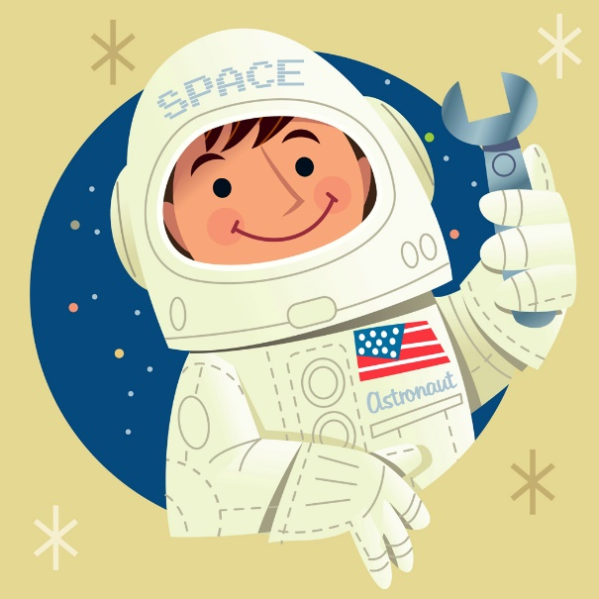

Sun: a star that gives us light and heat

Gravity: a force that holds planets in orbit

Orbit: the path of a planet

Axis: Imaginary pole running north to south upon which the Earth rotates

Revolution: the Earth’s movement in orbit around the sun

Rotate: to spin on an axis

24 Hours: time it takes Earth to rotate once

365 Days: time it takes Earth to revolve around the sun

Lunar Cycle: name for the moon’s phases

Moon’s Phases: new moon, waxing crescent, first quarter, waxing gibbous, full moon, waning gibbous, third quarter, waning crescent

We see the moon because it reflects the light from the sun. The moon does not glow.

The seasons are caused by the Earth’s tilt and its movement around the sun.

Day and night are caused by the Earth’s rotation on its axis.

